1994 Ford F700
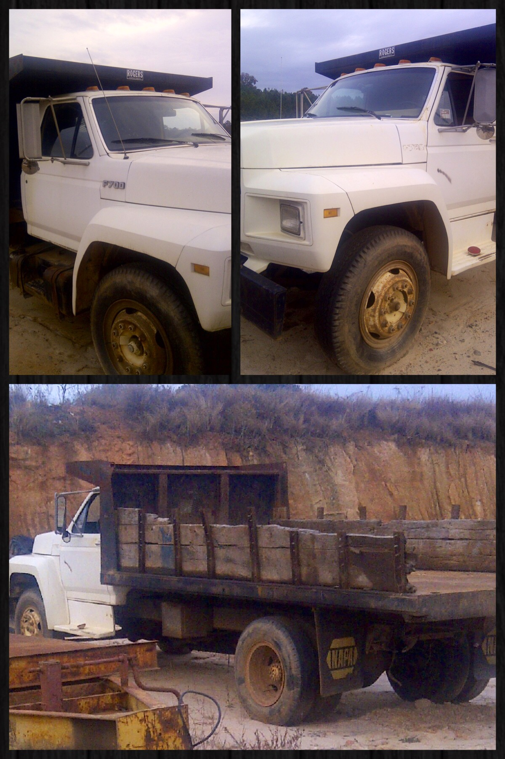
Sealed Bids will be accepted until noon April 25, 2014
Bids may be submitted to any Pinnacle Bank branch and forwarded to the Collections Department or directly to the Collections Department.
Sales Tax will be charged, unless documentation of exemption is provided.
For more information feel free to contact Amanda Miller at 706-213-3358 or by email at amandamiller@pinnaclebank.com

